Credit Card Analytics Report: A Power BI Dashboard Analysis

Author: Rahul Reddy

GitHub: https://github.com/RahuReddy/Credit-Card-Analytics-Report

Project Summary

To develop a comprehensive credit card weekly dashboard that provides real-time insights into key performance metrics and trends, enabling stakeholders to monitor and analyze credit card operations effectively.

Methodology

This analysis was conducted using a business intelligence workflow, which involved:

1. **Data Importing:** I collected the CSV files from the source, created a new database in SQL Server, and imported these CSV files into the SQL database. I then connected Power BI to the SQL Server to load the data.
2. **KPI Calculation:** Deriving key performance indicators (KPIs) such as total revenue, interest earned, and transaction counts for a high-level overview.
3. **Data Modeling & DAX:** Wrote DAX queries to create new measures and calculated columns. This included segmenting customers by age group and income and calculating metrics like current week revenue and previous week revenue for trend analysis.
4. **Visualization:** Using various charts and graphs to represent complex data, including revenue by age group, transaction type, and customer job.
5. **Insight Generation:** Analyzing the dashboard's visuals to identify key trends, patterns, and business opportunities.

DAX Queries

AgeGroup = SWITCH(

TRUE(),

cust_detail[Customer_Age] < 30, "20-30",

cust_detail[Customer_Age] >= 30 && cust_detail[Customer_Age] < 40, "30-40",

cust_detail[Customer_Age] >= 40 && cust_detail[Customer_Age] < 50, "40-50",

cust_detail[Customer_Age] >= 50 && cust_detail[Customer_Age] < 60, "50-60",

cust_detail[Customer_Age] >= 60, "60+",

"unkonown"

)

IncomeGroup = SWITCH(

    TRUE(),

    cust_detail[Income] < 35000, "Low",

    cust_detail[Income] >= 35000 && cust_detail[Income] < 70000, "Med",

    cust_detail[Income] >= 70000, "High",

    "unknown"

)

week_num2 = WEEKNUM(cc_detail[Week_Start_Date])

Revenue = cc_detail[Annual_Fees] + cc_detail[Total_Trans_Amt] + cc_detail[Interest_Earned]

Current_Week_Revenue = CALCULATE(

    SUM(cc_detail[Revenue]),

    FILTER(

        ALL(cc_detail),

        cc_detail[week_num2] = MAX(cc_detail[week_num2])))

Previous_Week_Revenue = CALCULATE(

    SUM(cc_detail[Revenue]),

    FILTER(

        ALL(cc_detail),

        cc_detail[week_num2] = MAX(cc_detail[week_num2])-1))

Key Insights and Analysis

The dashboard provides a detailed view of the credit card business, with insights broken down into two main areas: Transactional Insights and Customer Insights.

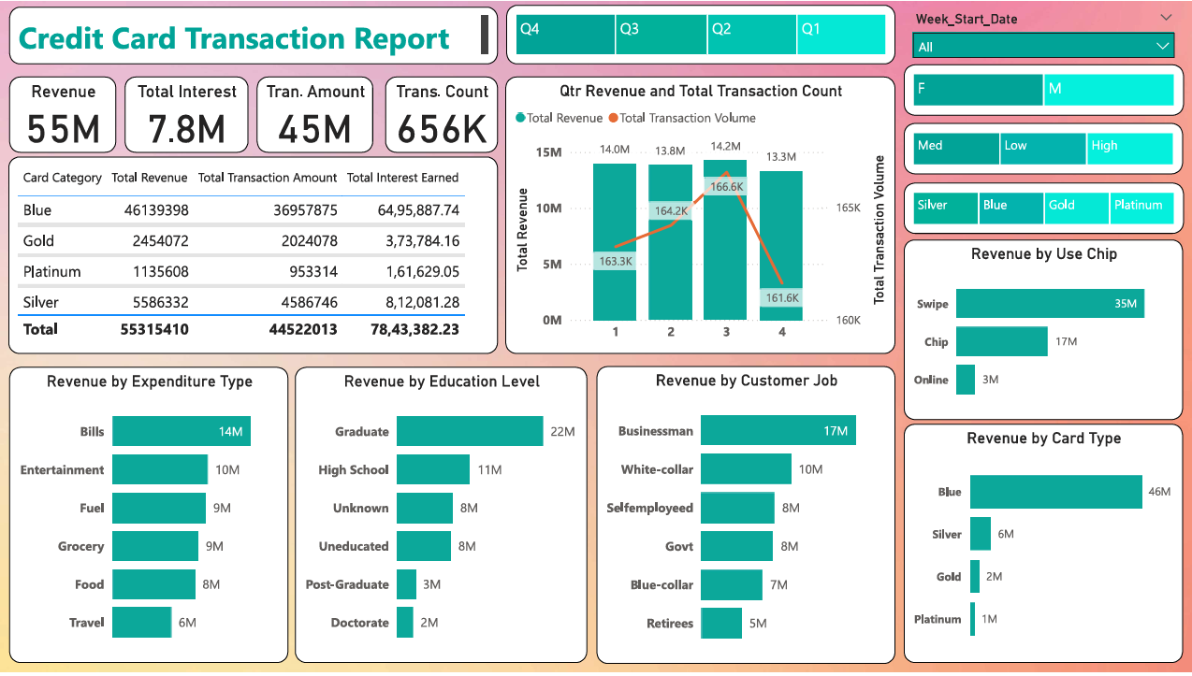

**1. Transactional Insights**

The analysis of transaction data highlights key trends in revenue, transaction volume, and card category performance.

* **Overall Performance:** The total revenue for the year 2023 was approximately **$55M**, with a total interest of **$7.8M**. The total transaction amount was around **$45M**, and the total transaction count was **656K**.
* **Quarterly Revenue:** The dashboard shows a consistent revenue trend throughout the year, with a slight dip in Q2. Q1 and Q3 had the highest revenues, at **$14.0M** and **$14.2M** respectively, while Q3 was slightly lower at **$13.8M** and **Q4** was the lowest of all at **$13.3M**.
* **Card Category Performance:** The **Blue** card category is the primary driver of revenue, accounting for **$46.1M** and generating over **$6.4M** in interest. The **Silver** card category follows with **$5.5M** in revenue.
* **Transaction Type:** The majority of transactions are categorized as **Swipe**, followed by **Chip** and **Online** transactions, indicating the most common payment methods used by customers.

**2. Customer Insights**

This section focuses on how different customer segments contribute to the business's revenue and profitability.

* **Revenue by Age Group:** The **40-50 age group** generates the highest revenue, at approximately **$14M**, followed by the **30-40** and **50-60** age groups. The **20-30** age group has the lowest revenue.
* **Revenue by Customer Job:** The **White-collar** and **Businessman** segments are the most profitable, generating over **$10M** and **$17M** in revenue respectively. This suggests these professional groups are the most active spenders.
* **Revenue by Education Level:** The dashboard indicates that customers with a **Graduate** and **High School** education level contribute the most to revenue.
* **Revenue by Demographic:** States like Texas, New York and California are majorly contributing to the revenue, their contribution adds up to **$38M** that is approximately **69%** to the total revenue.

**3. Additional and Week 52 Insights**

* Overall Credit Card Activation rate is **57.5%** in the given time period 30 days.
* Overall Delinquent rate is 6.06%. Customers with these jobs, fails to pay the credit card amount in the given time period typically 30 days. Selfemployed **1.65%,** followed by Govt **1.12%** andBusinessman **1.00%.**
* Male customers are contributing more to the revenue $31M, Female $26M.

**4. WOW Change for Week 52**

* Revenue slightly decreased by **-12.8%**
* Total Transaction Amount & Count decreased to **1.68%** & **1.71%** compared to previous **Week 51 1.94% & 1.92%**
* Customer Count decreased to **1.62%** compared to previous **Week 51 1.93%.**

Business Recommendations

Based on the insights derived from the analysis, here are a few key recommendations to optimize credit card performance:

* **Focus on High-Value Segments:** Given that **White-collar** and **Businessman** segments and the **40-50 age group** are the top revenue generators, targeted marketing and product offerings should be developed to further engage these customers. This could include premium rewards or exclusive offers.
* **Prioritize Popular Transactions:** Since **Swipe** and **Online** are the most common transaction types, it's important to ensure these methods are working well. The company should ensure a seamless and secure experience for these payment methods and focus on optimizing the experience for these transactions to keep customers happy.
* **Encourage Card Upgrades:** The **Blue** card category is the main revenue driver, but the higher-tier cards (**Gold** and **Platinum**) have lower transaction volumes. The company could launch a campaign to encourage high spending Blue cardholders to upgrade to premium cards, potentially increasing interest income and overall revenue.
* **Target Younger Demographics:** The **20-30 age group** has the lowest revenue contribution. A strategic initiative to attract younger customers, perhaps with a more youth-friendly rewards program or digital-first features, could help grow this segment.

Conclusion

This report demonstrates my ability to analyze complex financial data, identify key trends, and provide actionable business recommendations. The insights from this dashboard can serve as a powerful tool for stakeholders to make data-driven decisions that improve revenue, enhance customer relationships, and sustain business growth.

Future Work

* **Customer Lifetime Value:** Calculate and analyze CLV by segment.
* **Campaign ROI:** Track and measure the impact of card upgrade campaigns.
* **Automation:** Automate dashboard data refresh for real-time insights.